Invitation to register for coronavirus testing- personal care assistants (PAs)

You have been identified as a frontline worker, delivering vital services. You contacted your employer, requesting a test for coronavirus. Getting tested is important, so you can have clarity on whether you, or a family member, has the coronavirus and then you can either return to work or continue to isolate yourself and your household.

You are eligible for a test because:

- you have coronavirus symptoms – a new continuous cough or high temperature and are following government guidelines on self-isolating; or
- a member of your household has coronavirus symptoms meaning you are self-isolating in line with government guidelines

The test will take place at one of our Regional Test Sites. The sites operate a drive-through model, meaning you or a member of your household must drive to the site. We regret that we cannot test people who arrive on foot, take public transport or a taxi. People will also need access to a smartphone, in order to scan your test kits barcode in order to receive your results.

Please complete your registration using this online form. It is important you complete all of the fields accurately.

Who from your household takes this test?

You are a frontline worker who is self-isolating because you are displaying symptoms, meaning you are eligible to take this test.

You are a frontline worker who is self-isolating because someone else in your household is displaying symptoms, and that person is over the age of 18, then they are eligible to take the test.

You are a frontline worker who is self-isolating because an under 18-year-old in your household is displaying symptoms then they are eligible to take the test. A parent or guardian must perform the swab test on 5-11-year olds. 12-18-year olds can perform the test on themselves. The test is unsuitable for under-fives. This test would still take place at a Regional Test Site. The list of sites and who can be tested at them is on page 3.

Receiving your results

You will receive your results by text or email within 48 hours of taking the test. Please ensure you enter the correct contact details when you register.

When you arrive at the Regional Test Site

Location details will be sent to you in your confirmation email. You must present your employer-issued staff ID on arrival along with the confirmation email. If you do not have an employer-issued staff ID- for example, if you are a Personal Care Assistant (PA)- you will need to present your confirmation email along with the filled out temporary PA ID that can be found on page four of this document.

Test Sites are usually open 1000 – 1600. This helpful video shows you what to expect at a drive-thru test site.

Instructions when you visit a Regional Test Centre

To avoid risk of cross-contamination, our centre is a drive-through. You must arrive by car (not on foot, via public transport, by taxi or by any other means). Only people from your household may be in the car with you.

- Do not exit the car at any point whilst on site.

- Please note, bathroom facilities will not be available.

- When you arrive at the main gate DO NOT lower your windows.

- Once you are on site, we will use the car registration that you have provided to identify you. This is how you gain access to the site.

- Please press your employer-issued staff ID against the window for site security to see. If you are a PA and do not have an employer-issued staff ID, please present your confirmation email from registration, along with the filled out temporary PA ID that can be found on page four of this document. If you are unable to print these, please show as an electronic copy on your smart phone.

- You will be directed to a testing lane, where a member of our trained National Testing Team will instruct you to lower your window to carry out a coronavirus test.

- Please note that your test may be either assisted or self-administered – you will be directed by a member of staff on site.

- You will then be instructed to follow the link on your phone which will enable you to scan your test kit’s barcode.

- Your results will then be sent back to your phone by text or by email within 48 hours.

When you are at the test station please:

- Park with your handbrake on
- Turn your engine off
- Turn your radio off
- Have your smart phone ready for after your test, to scan the barcode of the test kit

List of Regional Test Sites

Please note that only sites labelled as “self-test” can accommodate testing for under-18s.

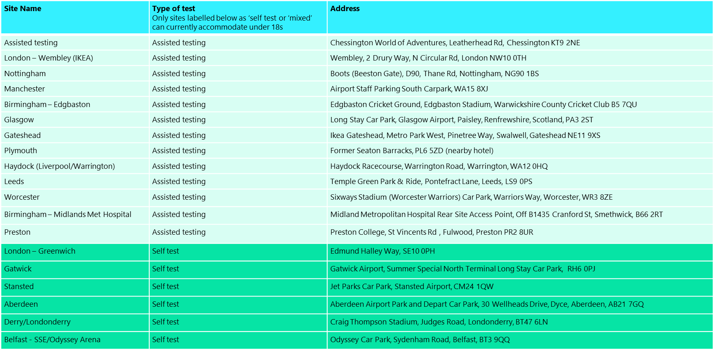

…………………………
…………………………
…………………………

Tel: …………………
Email: …………………

To whom it may concern

Confirmation of employment and eligibility for testing- letter of ID

This letter is to verify that …………………………. is employed as my Personal Care Assistant.

On 17th April, the Government announced that testing would be made available to all health and social care staff. This includes Personal Care Assistants, who have been deemed key frontline workers, and as such, are eligible to receive a test.

Given many Personal Care Assistants are directly employed by individuals, rather than directly by the CCG or Local Authority themselves, they may not have an employer-issued staff ID. This letter therefore serves that purpose.
If you require further verification of the employment of ……………………… please contact me on the number above.

Yours sincerely

…………………………………..

Can also be found at https://bit.ly/2XRDL56

